Extra Practice 1

Lesson 1: Measuring Length
Master 4.26

Use a ruler to help you.

Copy and complete.

1. a) 9 cm = ______ mm b) 40 cm = _____ mm c) 23 cm = _____ mm

2. a) 70 mm = ____ cm b) 50 mm = _____ cm c) 90 mm = _____ cm

3. a) 3000 mm _____ m b) 8000 mm = _____ m c) 5000 mm = _____ m

4. a) 4 m = _____ mm b) 7 m = _____ mm c) 1 m = _____ mm

5. Which unit would you use to measure each item?
a) the length of a paperclip b) the width of a book
c) the height of a tall tree d) the thickness of a penny

6. Draw each object. Measure and record its length in millimetres.
a) a crayon b) a worm c) a buckle

7. Draw a picture of each item.
a) a snake 15 cm long b) a pine cone 57 mm long
c) a pencil case 12 cm wide and 20 cm long

8. Use >, <, or =
a) 7 cm  70 mm b) 140 mm  11 cm
c) 80 mm  9 cm d) 24 mm  2.4 cm

9. Which unit would you use to measure each item?
a) the width of a slice of bread
b) the thickness of a sandwich
c) the length of a playground
d) the length of a staple

Extra Practice 3

Lesson 3: Exploring Rectangles with Equal Perimeters
Master 4.27

Use 1-cm grid paper.

1. Draw all possible rectangles with each perimeter.
a) 14 cm b) 8 cm c) 18 cm

2. Draw 2 different rectangles with each perimeter – the rectangle with the
least area and the rectangle with the greatest area.
Find the area of each rectangle.
a) 16 cm b) 20 cm

3. Draw a rectangle with each perimeter and area.
a) perimeter 24 cm and area 32 cm²
b) perimeter 22 cm and area 18 cm²
c) perimeter 22 cm and area 28 cm²

4. Anju has 48 m of fencing to put around his garden.
a) List all the possible lengths and widths of Anju’s garden.
b) Which dimensions will Anju choose if he wants the garden with the greatest possible area? The least possible area?

5. a) Use 1-cm grid paper. Draw a rectangle 12 cm long and 8 cm wide.
b) What is the perimeter of the rectangle?
What is the area of the rectangle?

6. a) Draw a rectangle with the same perimeter but greater area than the rectangle you drew in question 5.
b) Draw a rectangle with the same perimeter but lesser area.

Extra Practice 4
Master 4.28

Lesson 4: Exploring Rectangles with Equal Areas

Use 1-cm grid paper.

1. Draw a rectangle with each area and perimeter.
a) area 24 cm² and perimeter 28 cm
b) area 16 cm² and perimeter 16 cm
c) area 18 cm² and perimeter 38 cm
d) area 20 cm² and perimeter 24 cm

2. Draw all the possible rectangles with each area.
a) 12 cm² b) 13 cm² c) 36 cm²

3. Draw a rectangle with area 36 cm² and the least possible perimeter.
4. Draw a rectangle with area 10 cm² and the greatest possible perimeter.
5. a) Use grid paper. Draw all the possible rectangles with area
24 square units.
b) Find and record the perimeter of each rectangle.
c) Describe the rectangle with the greatest perimeter.
d) Describe the rectangle with the least perimeter.

6. Find the area and perimeter of a square with:
a) 1-cm sides b) 2-cm sides
c) 3-cm sides d) 4-cm sides
e) 8-cm sides f) 10-cm sides

Extra Practice 5
Master 4.29

Lesson 5: Exploring Volume

1. Find a small box.
Estimate its volume in dried beans.
Fill the box to check your estimate.
Record your work.

2. Suppose you filled the box in question 1 with chestnuts.
Would you need more or less chestnuts than dried beans to fill your box?
Explain your answer.

3. Find a small cup.
Estimate its volume in lima beans.
Fill the cup to check your estimate.
Record your work.

4. Suppose you filled a small box with chestnuts and counted 15 chestnuts.
Then you filled the same box with acorns.
About how many acorns do you think it took? Explain your answer.

5. Which item in each set would you use to get the best measure of the volume of a chocolate box? Explain your choices.
a) ping-pong balls, marbles, or orange Pattern Blocks
b) sugar cubes, popcorn kernels, or chestnuts

6. Kiko made a rectangular garden with an area of 60 m².
a) Find the dimensions of all the possible rectangles.
b) Record the perimeter of each rectangle.

Extra Practice 6
Master 4.30

Lesson 6: Measuring Volume in Cubic Centimetres

1. Find the volume of each rectangular prism.
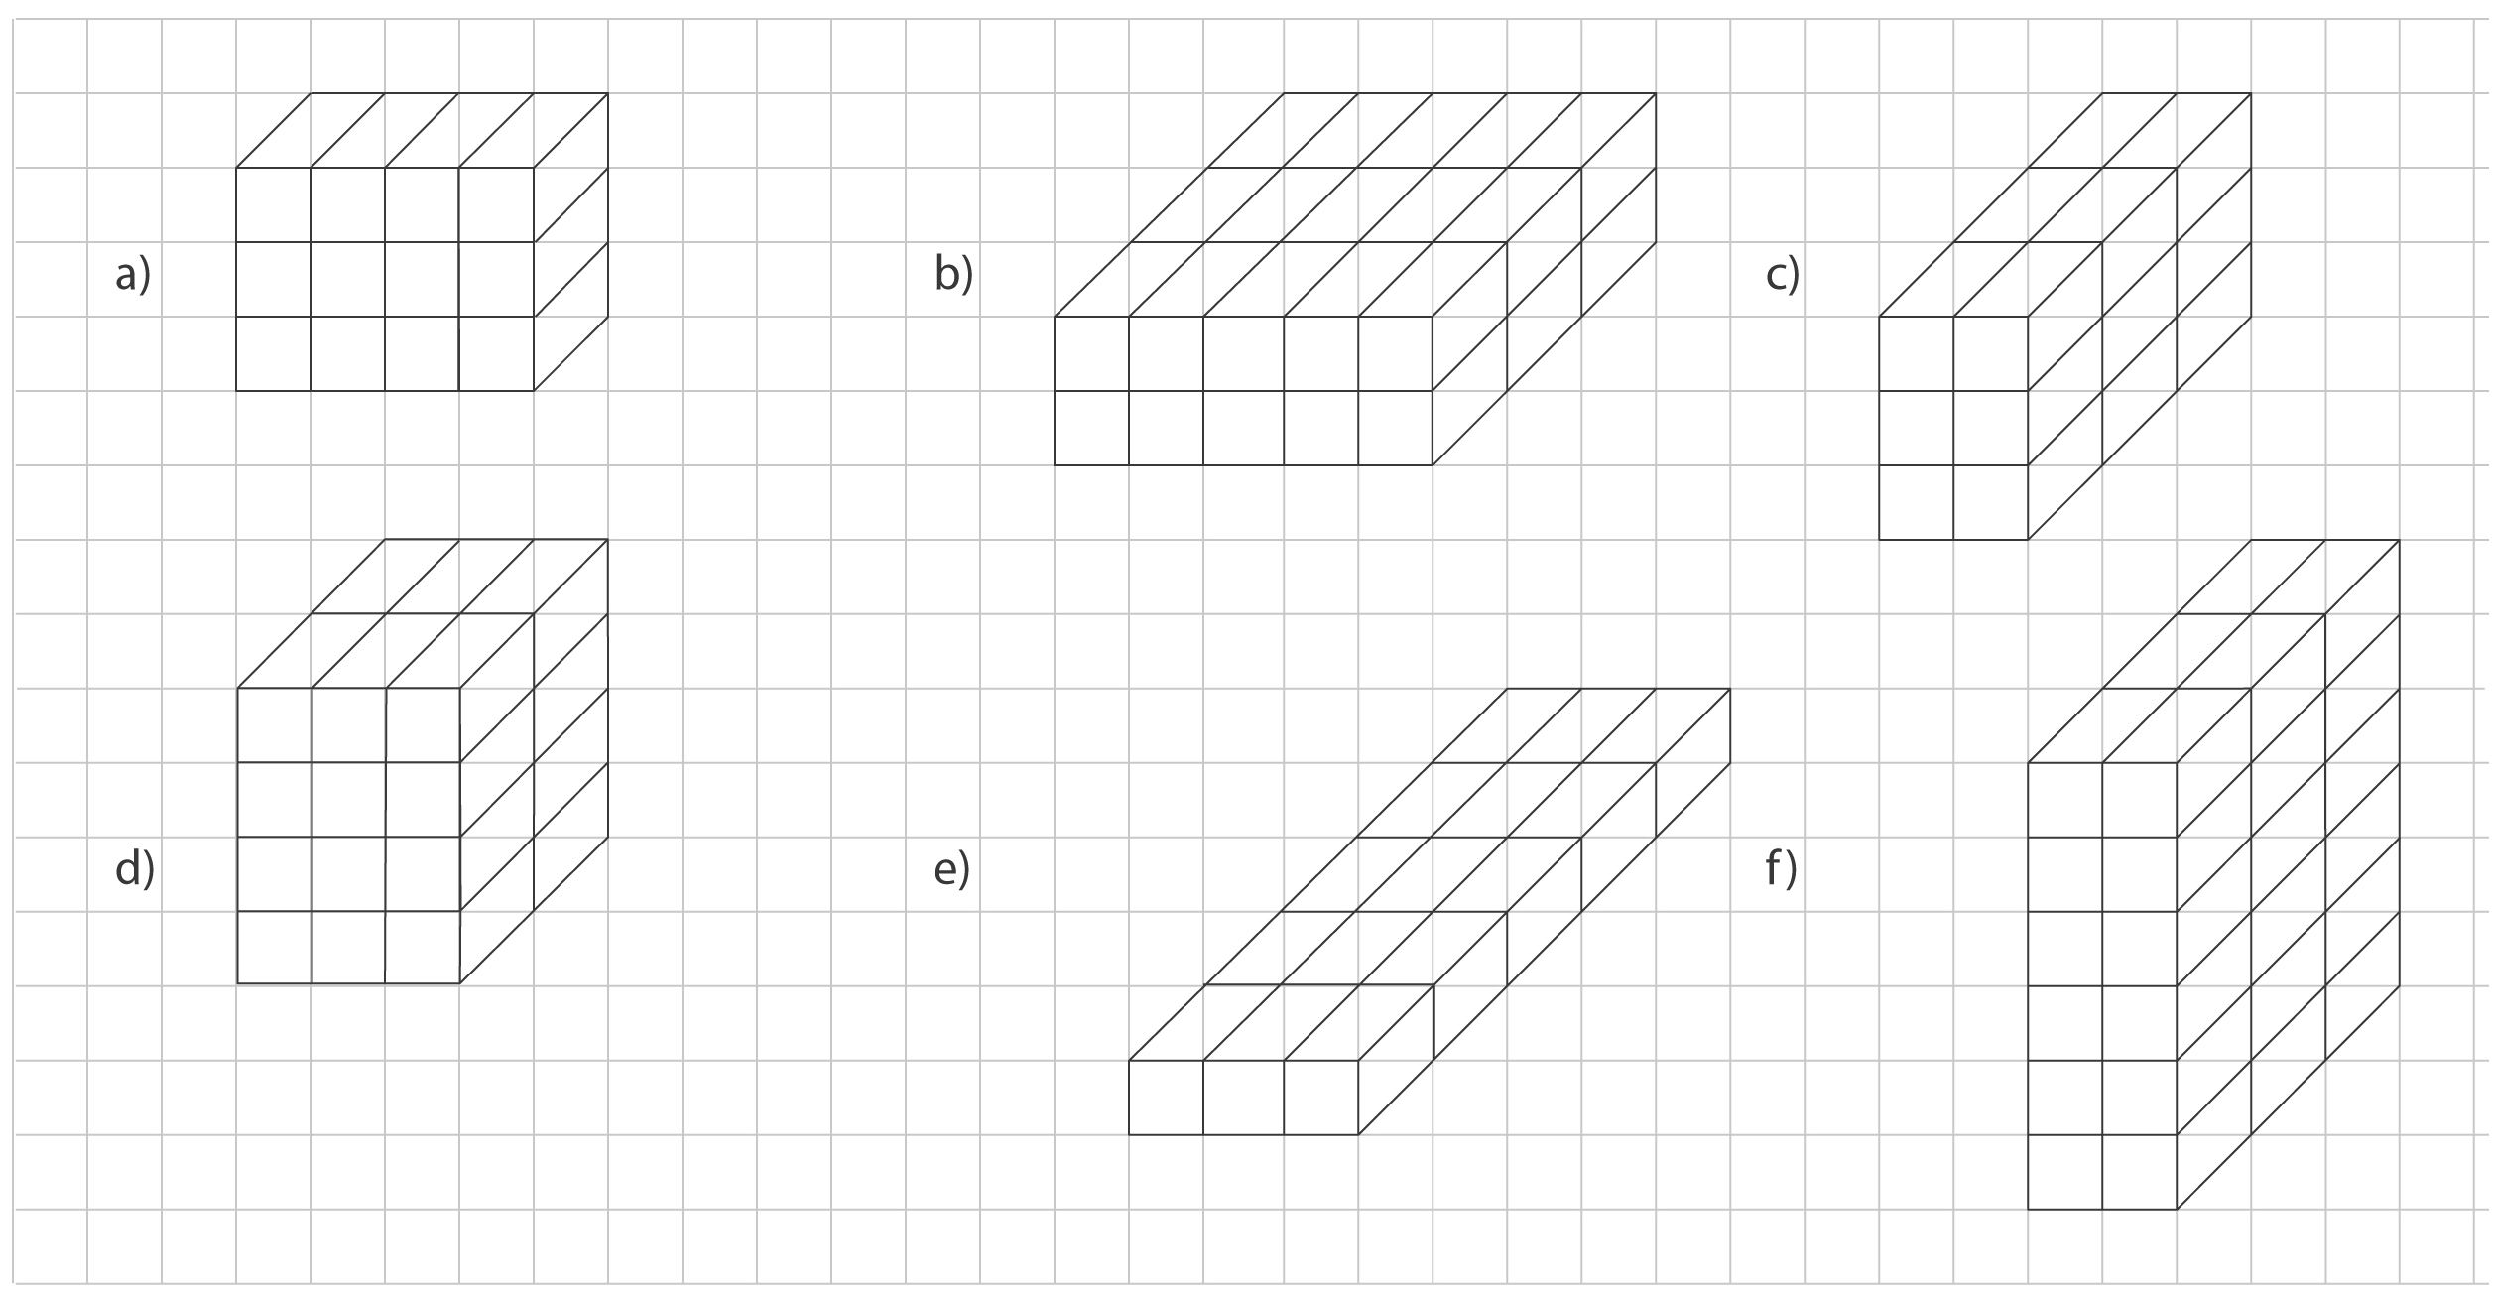
2. Order the prisms in question 1 from greatest to least volume.

3. Find 3 small boxes.
Estimate to order the boxes from least to greatest volume.
Determine the volume of each box using centimetre cubes.
Was your estimate correct?

4. A box has a volume of 16 cm³ .
The box is 4 cm tall.
a) How many centimetre cubes will fit in one layer of the box?
How do you know?
b) How long and how wide might the box be?
Give as many answers as possible.

5. Describe a strategy you could use to find the volume of your lunch box
in cubic centimetres.

Extra Practice 7
Master 4.31

Lesson 7: Constructing Rectangular Prisms with a Given Volume

Use centimetre cubes.

1. Build a rectangular prism with each volume.
Record your work in a table.

a) 12 cm³ b) 24 cm³
c) 16 cm³ d) 11 cm³

2. Build all the possible rectangular prisms with volume 18 cm³.
Record your work in a table.
Volume | Length | Width | Height

3. Build a rectangular prism with each set of dimensions shown in the table. Find the volume of each prism.

Length (cm) | Width (cm) | Height (cm) | Volume (cm³)
3 | 4 | 2
8 | 2 | 1
4 | 5 | 2
6 | 3 | 2

4. a) How many different rectangular prisms can be made with 28 centimetre cubes? Write the dimensions of each prism.
b) Suppose the number of centimetre cubes were halved. How many different rectangular prisms could be made? Write their dimensions.

5. Suppose you want to build a rectangular prism with 35 centimetre cubes.
You put 7 cubes in the bottom layer.

a) How many layers of cubes will you need?

b) What are the dimensions of the prism?

Extra Practice 8
Master 4.32

Lesson 8: Measuring Volume in Cubic Metres

Use centimetre cubes.

1. Estimate the volume in cubic metres of each object.
a) a playpen b) a school bus c) a refrigerator

2. Would you use cubic centimetres or cubic metres to measure the volume of each item?
a) a donut box b) your classroom c) a cargo ship
d) a pencil box e) a tissue box f) a garage

3. Each rectangular prism below is built with 1 metre cube.
Find the volume of each prism.
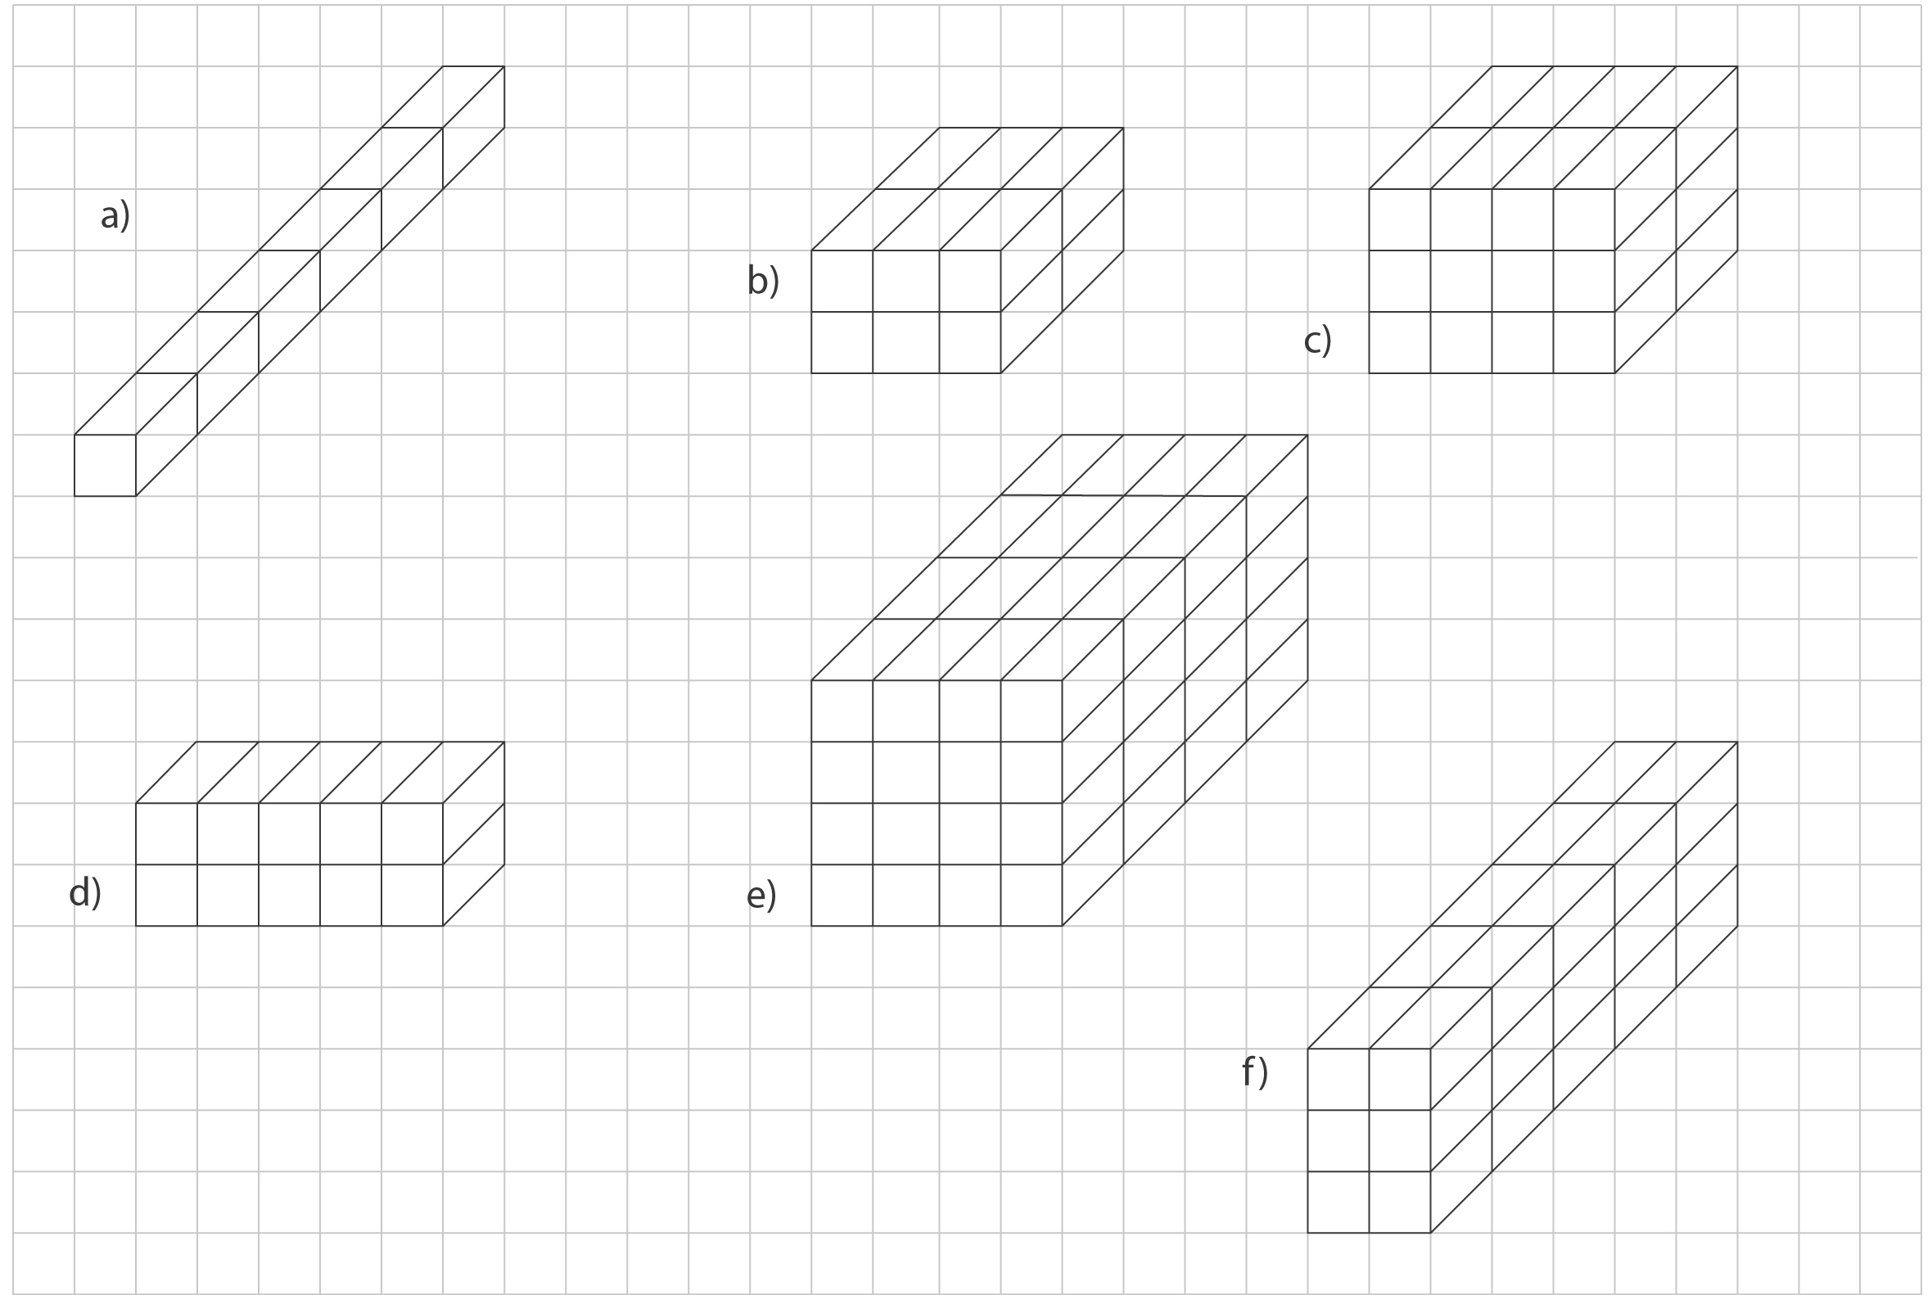
4. a) Name 2 items you would measure using cubic centimetres.
b) Name 2 items you would measure using cubic metres.

Extra Practice 9
Master 4.33

Lesson 9: Exploring Capacity: The Litre

Use centimetre cubes.

1. Choose the better estimate.
a) a jug of orange juice 4 L or 40 L
b) a wading pool 2 L or 200 L
c) a pail 10 L or 100 L
d) a bottle of ketchup 1 L or 10 L

2. One litre fills about 4 glasses.
About how many glasses can you fill with each?
a) a 4-L jug of punch b) a 2-L bottle of soda
c) a 3-L jug of lemonade d) a 10-L container of water

3. a) Find 2 containers you think have capacities greater than one litre.
Find the capacity of each container.
b) About how many glasses of liquid do you think each of your containers holds? Explain.

4. Name 3 things that are measured in litres.

5. Which containers hold more than one litre?
a) an automobile’s gasoline tank
b) a baby bottle
c) an eyedropper
d) a punch bowl
e) a wading pool

Extra Practice 10
Master 4.34

Lesson 10: Exploring Capacity: The Millilitre

1. Choose the better estimate.
a) an eyedropper 1 mL or 200 mL
b) a teacup 25 mL or 250 mL
c) a bottle of shampoo 75 mL or 750 mL
d) a water bottle for a gerbil 6 mL or 250 mL

2. Would you use millilitres or litres to measure each container?
a) a teaspoon b) a drinking glass c) a vinegar jug
d) an aquarium e) a soup bowl f) a drink box

3. Order from least to greatest capacity.
a) 2 L, 1000 mL, 40 mL, 750 mL
b) 76 mL, 14 mL, 5 L, 17 mL, 17 L

4. Copy and complete.

a) 3 L = _____ mL b) 7 L = _____ mL c) 10 L = _____ mL

d) 2000 mL = _____ L e) 9000 mL = _____ L f) 1000 mL = _____ L

5. Which measure is closest to 1 L? How do you know?
750 mL, 289 mL, 904 mL, 167 mL

6. Jerry drank 375 mL of water from his 1-L bottle.
How much water is left in Jerry’s bottle?

7. Mabel poured 680 mL of juice into a 1-L jug.
How many more millilitres will the jug hold?

Extra Practice 11
Master 4.35

Lesson 11: Relating Capacity and Volume

1. Describe how you could find the volume of a basketball in
cubic centimetres.

2. Shawn says that the volume of a rectangular prism is 32 cm³.
Maria says the volume is 32 mL.
Who is correct? Explain.

3. a) Estimate the volume of 10 quarters.
b) Find the volume of 10 quarters.
c) How does your estimate compare to the volume you measured?

4. Use modelling clay to make a sphere.
a) Estimate the volume of the sphere.
b) Find the volume of the sphere.

5. Use modelling clay to make 1 bigger and 1 smaller sphere than the one you made in question 4.
a) Estimate their volumes.
b) Find their volumes.
c) What strategy did you use to estimate their volumes?

Extra Practice Sample Solutions
Master 4.36

Extra Practice 1 – Master 4.26

Lesson 1: Measuring Length
1. a) 9 cm = 90 mm b) 40 cm = 400 mm c) 23 cm = 230 mm
2. a) 70 mm = 7 cm b) 50 mm = 5 cm
c) 90 mm = 9 cm
3. a) 3000 mm = 3 m b) 8000 mm = 8 m
c) 5000 mm = 5 m
4. a) 4 m = 4000 mm b) 7 m = 7000 mm
c) 1 m = 1000 mm
5. a) millimetre b) centimetre
c) metre d) millimetre
6. Student answers should consist of drawings of a crayon, a worm, and a buckle with their lengths labelled in millimetres.
7. a) Student answers should show a snake
15 cm long.
b) Student answers should show a pine cone 57 mm long.
c) Student answers should show a pencil case 12 cm wide and 20 cm long.
8. a) = b) > c) < d) =
9. a) cm b) mm c) m d) mm

Extra Practice 3 – Master 4.27
Lesson 3: Exploring Rectangles with Equal Perimeters
1. a)
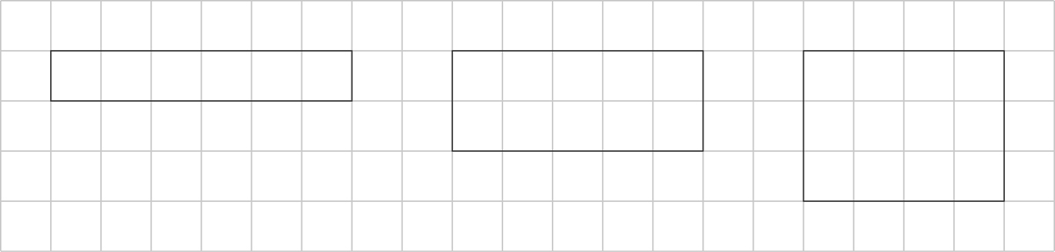
b)
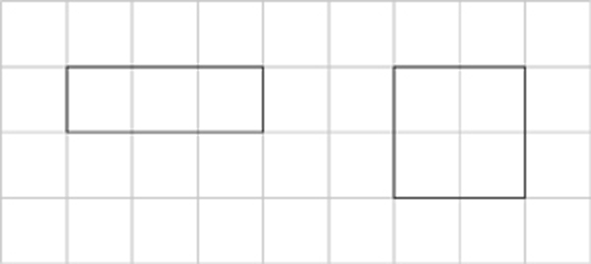
c)
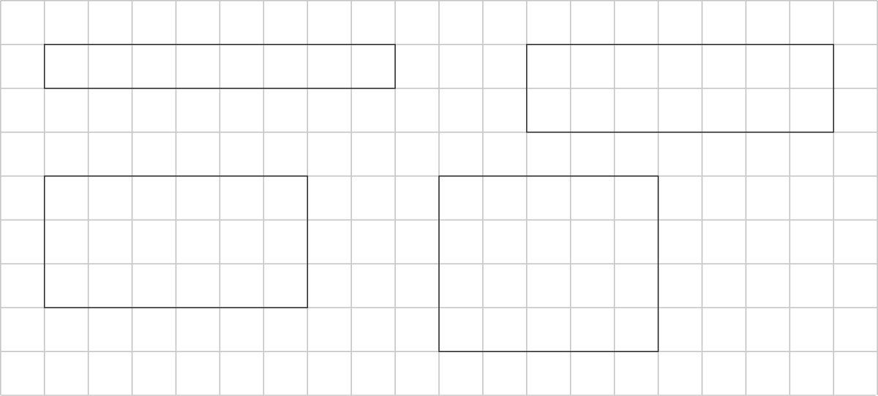

2. a)
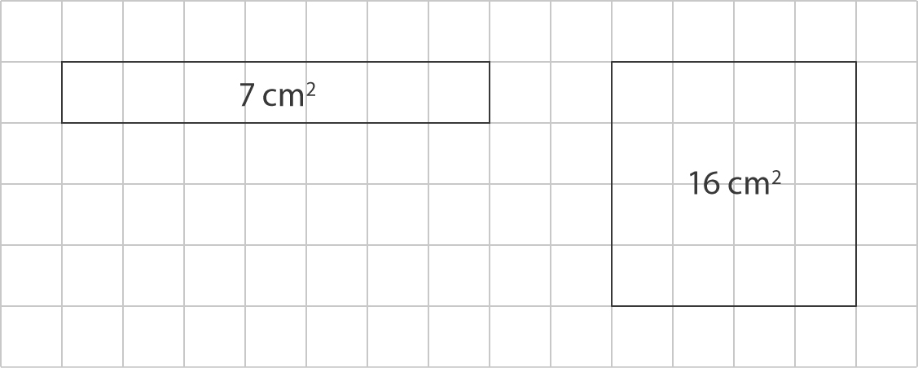

b)
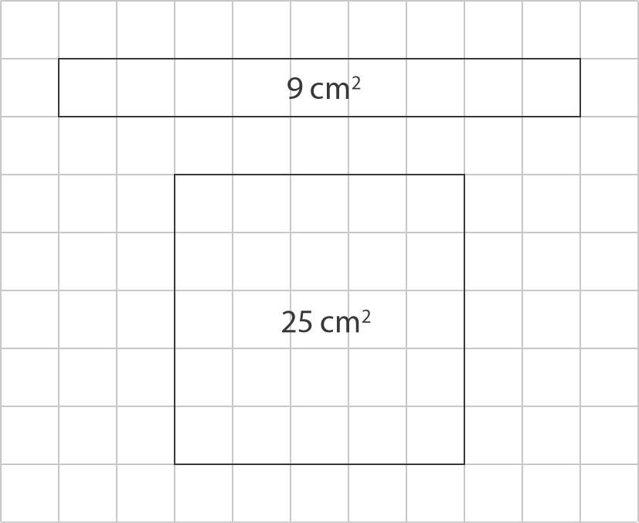
3. Student drawings should be rectangles with the following dimensions:
a) 8 cm × 4 cm
b) 9 cm × 2 cm
c) 7 cm × 4 cm
4. a) 1 m × 23 m, 2 m × 22 m, 3 m × 21 m,
4 m × 20 m, 5 m × 19 m, 6 m × 18 m,
7 m × 17 m, 8 m × 16 m, 9 m × 15 m,
10 m × 14 m, 11 m × 13 m, 12 m × 12 m
b) least area: 1 m × 23 m
greatest area: 12 m × 12 m

5. a) Student drawings should show a
12 cm × 8 cm rectangle drawn on
1-cm grid paper.
b) perimeter: 40 cm, area: 96 cm²
6. a) For example: student drawings could show a 10 cm × 10 cm square.
b) For example: student drawings could show a 6 cm × 14 cm rectangle.

Extra Practice 4 – Master 4.28
Lesson 4: Exploring Rectangles with Equal Areas
1. a)
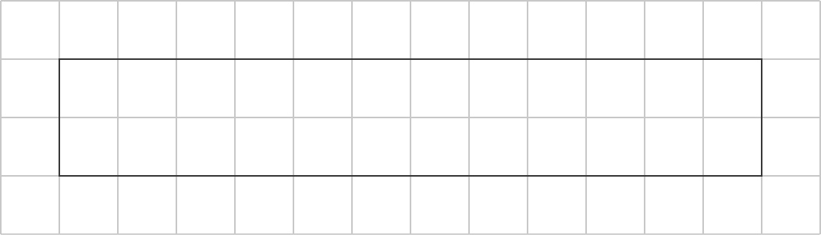

b)
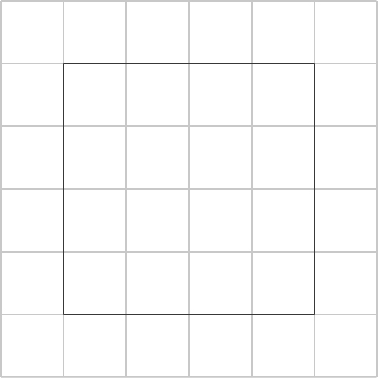

c)
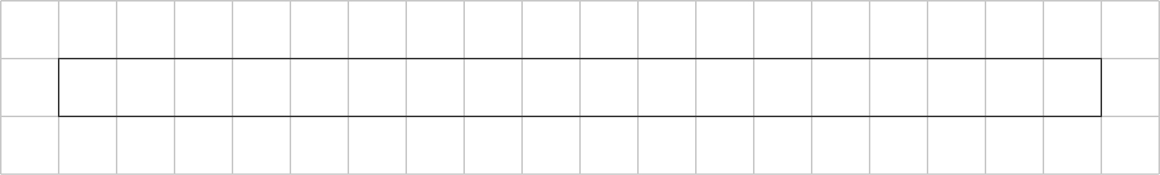

d)
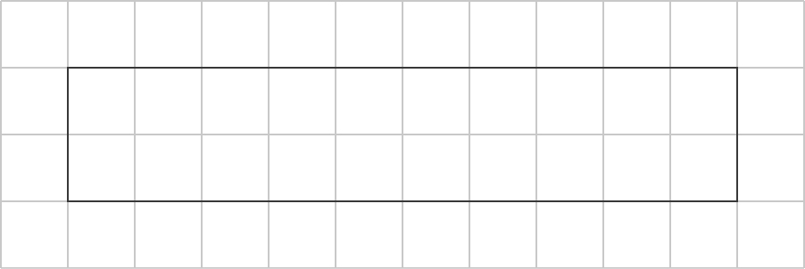

2. a)
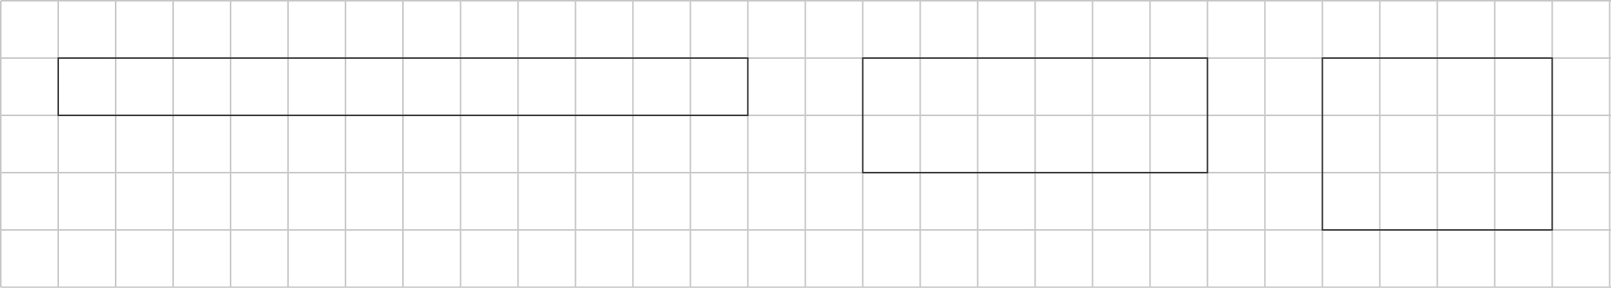

b)
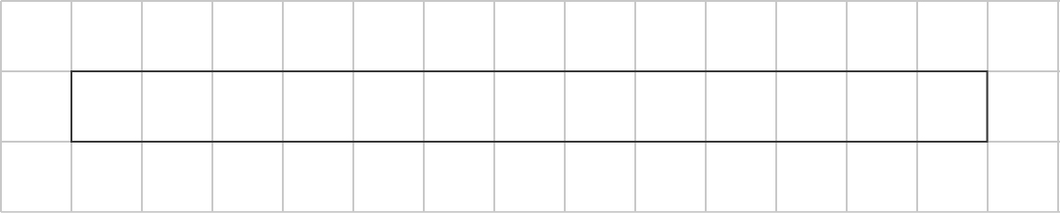

c)
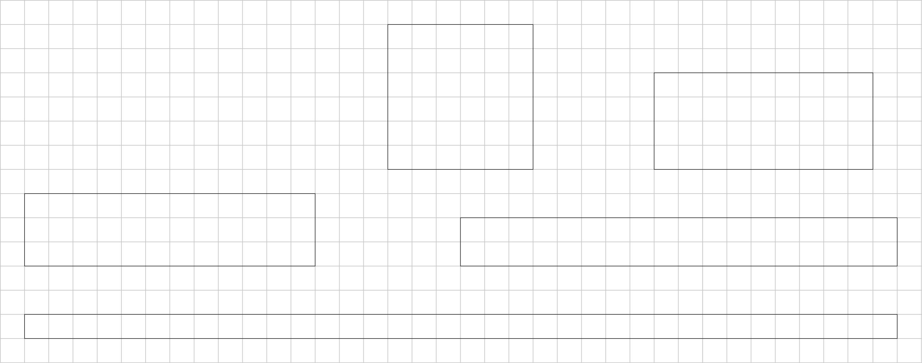

3.
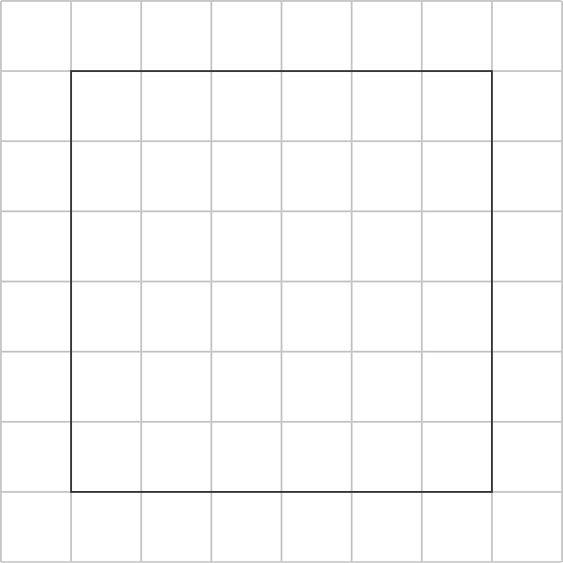

4.
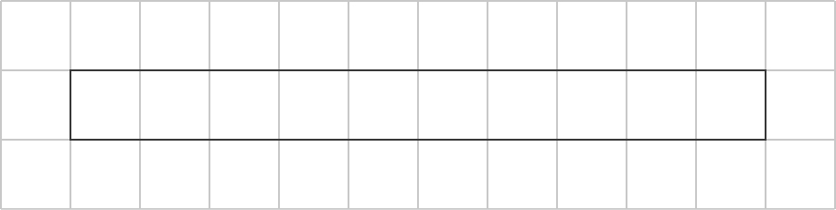

5. Student drawings should show rectangles on grid paper with the following dimensions:
a) 1 square unit by 24 square units
2 square units by 12 square units
3 square units by 8 square units
4 square units by 6 square units
b) 50 square units
28 square units
22 square units
20 square units
c) The rectangle with the greatest perimeter is long and thin.
d) The rectangle with the least perimeter is close to a square.
6. a) A = 1 cm², P = 4 cm
b) A = 4 cm², P = 8 cm
c) A = 9 cm², P = 12 cm
d) A = 16 cm², P = 16 cm
e) A = 64 cm², P = 32 cm
f) A = 100 cm², P = 40 cm

Extra Practice 5 – Master 4.29

Lesson 5: Exploring Volume
1. For example: Estimate: 50 beans,
Actual volume: 73 beans
2. For example: Chestnuts are bigger and take up more space than dried beans, so fewer would be needed to fill the box.
3. For example: Estimate: 40 lima beans, Actual volume: 53 lima beans
4. For example: I think it would take about
30 acorns because acorns are about half as big as chestnuts.
5. a) For example: I would use orange Pattern Blocks because they can be placed in a box without spaces between them.
b) For example: I would use sugar cubes because the other objects cannot be packed in a box without spaces between them.
6. a) 1 m by 60 m, 2 m by 30 m, 3 m by 20 m,
4 m by 15 m, 5 m by 12 m, 6 m x 10 m
b) 122 m, 64 m, 46 m, 38 m, 34 m, 32 m

Extra Practice 6 – Master 4.30
Lesson 6: Measuring Volume in Cubic Centimetres
1. a) 12 cm³ b) 30 cm³ c) 18 cm³
d) 24 cm³ e) 15 cm³ f) 36 cm³
2. f, b, d, c, e, a
3. Volumes will vary depending on the boxes chosen. Answers should indicate that students employ good strategies in estimating volume.
4. a) 4 cubes will fit in one layer because there are 4 layers and just 16 cubes in all.
b) 1 cm × 4 cm or 2 cm × 2 cm
5. I would put a line of centimetre cubes along the length and width of my lunch box and count how many were in each line. Then I would multiply these numbers to get the number of cubes in a layer. Next, I would stack cubes to the top of the lunch box to find how many layers would fit in it. I would multiply the number of layers by the number of cubes in a layer to get the total volume.

Extra Practice 7 – Master 4.31
Lesson 7: Constructing Rectangular Prisms with a Given Volume
1. For example:

2.
 | Volume | Length | Width | Height
a) | 12 cm³ | 3 cm | 1 cm | 4 cm
b) | 24 cm³ | 6 cm | 2 cm | 2 cm
c) | 16 cm³ | 4 cm | 4 cm | 1 cm
d) | 11 cm³ | 11 cm | 1 cm | 1 cm
Volume | Length | Width | Height
18 cm³ | 18 cm | 1 cm | 1 cm
18 cm³ | 9 cm | 2 cm | 1 cm
18 cm³ | 6 cm | 3 cm | 1 cm
18 cm³ | 3 cm | 3 cm | 2 cm

3. a) 24 cm³ b) 16 cm³ c) 40 cm³
d) 36 cm³
4. a) 28 cm × 1 cm × 1 cm,
14 cm × 2 cm × 1 cm,
7 cm × 4 cm × 1 cm,
7 cm × 2 cm × 2 cm
b) 14 cm × 1 cm × 1 cm,
7 cm × 2 cm × 1 cm
5. a) 5 layers
b) 7 cm × 1 cm × 5 cm

Extra Practice 8 – Master 4.32
Lesson 8: Measuring Volume in Cubic Metres
1. For example:
a) 1 m³ b) 24 m³ c) 2 m³
2. a) cubic centimetres b) cubic metres
c) cubic metres d) cubic centimetres
e) cubic centimetres e) cubic metres

3. a) 6 m³ b) 12 m³ c) 24 m³ d) 10 m³
e) 64 m³ f) 30 m³
4. For example:
a) a doughnut box, a tissue box
b) a freezer, a dog house

Extra Practice 9 – Master 4.33

Lesson 9: Exploring Capacity: The Litre
1. a) 4 L b) 200 L c) 10 L d) 1 L
2. a) 16 b) 8 c) 12 d) 40
3. a) For example: I picked a bucket and a dishwashing liquid container. The bucket held 10 L and the dishwashing liquid container held 3 L.
b) Each litre fills about 4 glasses, so the bucket holds about 40 glasses and the dishwashing liquid container holds about 12 glasses.
4. For example: milk, ice cream,
and cooking oil
5. a, d, and e

Extra Practice 10 – Master 4.34

Lesson 10: Exploring Capacity:
The Millilitre
1. a) 1 mL b) 250 mL c) 750 mL d) 250 mL
2. a) millilitres b) millilitres c) litres
d) litres e) millilitres f) millilitres
3. a) 40 mL, 750 mL, 1000 mL, 2 L
b) 14 mL, 17 mL, 76 mL, 5 L, 17 L
4. a) 3000 mL b) 7000 mL c) 10 000 mL
d) 2 L e) 9 L f) 1 L
5. 904 mL is closest to 1 L because
1 L = 1000 mL and 904 is closer to 1000 than the other numbers.
6. 1000 – 375 = 625 mL
7. 320 mL

Extra Practice 11 – Master 4.35

Lesson 11: Relating Capacity and Volume
1. For example: I would fill a pail to its top with a measured amount of water. Then I would completely submerge the basketball in the pail so that water overflowed the pail. Next, I would remove the basketball and measure the amount of water remaining in the pail. The difference between the first and last measurements is the volume of the basketball.
2. Both students are correct because
32 cm³ = 32 mL.
3. a) For example: about 10 mL
b) About 8 mL
c) For example: My estimate was higher than the volume.
4. Answers will vary depending upon the size of the sphere made. Estimates and measured volumes should be reasonably close.
5. Answers will vary depending upon the size of the spheres made. Estimates and measured volumes should be reasonably close. Students’ strategies should indicate that they used the volume of the first sphere to estimate the volumes of the larger and smaller spheres.

