Extra Practice 1
Lesson 1: Describing Shapes
Master 6.31
Use Pattern Blocks.
1. a) Trace each Pattern Block. Label its vertices.
- Name the equal sides.
- Name the parallel sides.
Shape | Equal Sides | Parallel Sides

Extra Practice 2
Lesson 2: Investigating Perpendicular Sides
Master 6.32
- Use a geoboard. Then draw each shape below.
Make and draw a shape that has:
  - exactly 2 horizontal sides and 2 vertical sides
  - at least 1 horizontal side and exactly 2 perpendicular sides
  - exactly 1 pair of perpendicular sides and at least 2 vertical sides


- Label the vertices of the shapes you drew in question 1.

a) Name the horizontal sides.

b) Name the vertical sides.

c) Name the perpendicular sides.

Extra Practice 3
Lesson 3: Investigating Quadrilaterals
Master 6.33
- Answer each riddle.
a) I have two pairs of parallel sides.
All my sides are equal.
All my angles are right angles.
What am I?

b) I have 4 sides.
I have only 1 pair of parallel sides.
What am I?

c) I have 2 pairs of equal sides.
I have no parallel sides.
What am I?

- Draw each shape in question 1.

- For each shape in question 1, name other attributes.

a)

b)

c)

Extra Practice 4
Lesson 4: Other Attributes of Quadrilaterals
Master 6.34
1. Draw a quadrilateral that has:
a) exactly 1 line of symmetry
b) exactly 2 lines of symmetry
c) 4 lines of symmetry
d) 0 lines of symmetry
Draw as many different quadrilaterals as you can each time.


2. Label each quadrilateral in question 1 with a letter.
Which quadrilaterals in question 1 have perpendicular sides?

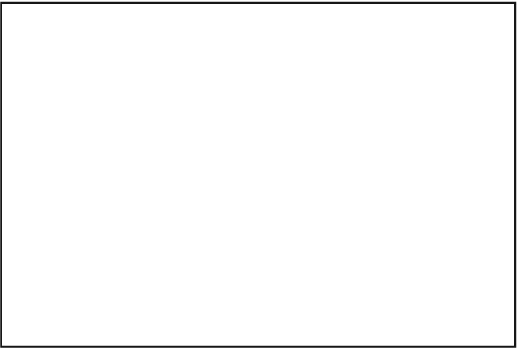
3. Sort the quadrilaterals in question 1 in
the Venn diagram. Use the attributes:
“Has equal sides” and “Has parallel sides”

Extra Practice 6
Master 6.35
Lesson 6: Exploring Faces and Edges of Objects
For each object below, where possible, identify:
a) 2 parallel faces b) 2 perpendicular faces
c) 2 intersecting faces d) 2 vertical faces
e) 2 horizontal faces f) 2 parallel edges
g) 2 perpendicular edges h) 2 intersecting edges
i) 2 vertical edges j) 2 horizontal edges

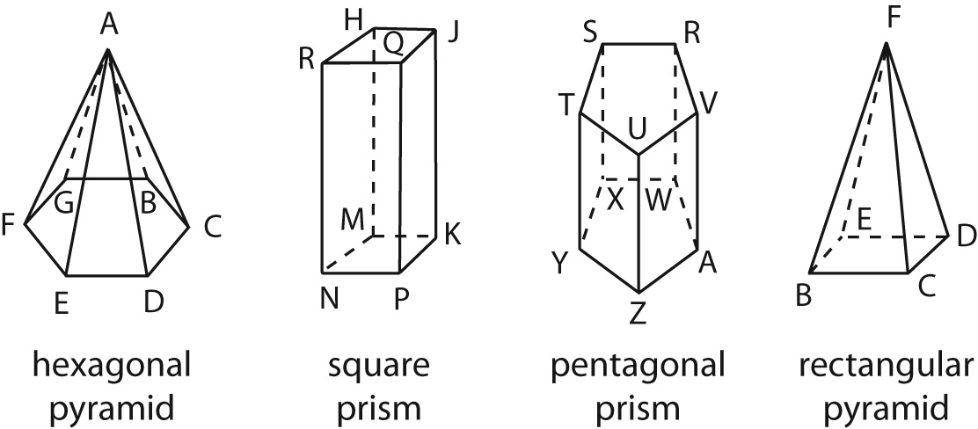

1. a) _________ 2. a) _________ 3. a) _________ 4. a) _________
b) _________ b) _________ b) _________ b) _________
c) _________ c) _________ c) _________ c) _________
d) _________ d) _________ d) _________ d) _________
e) _________ e) _________ e) _________ e) _________
f) _________ f) _________ f) _________ f) _________
g) _________ g) _________ g) _________ g) _________
h) _________ h) _________ h) _________ h) _________
i) _________ i) _________ i) _________ i) _________
j) _________ j) _________ j) _________ j) _________

Extra Practice 7
Master 6.36
Lesson 7: Drawing Objects
1. Name a prism that has each set of faces:
a) squares and rectangles
b) triangles and rectangles
c) rectangles and hexagons

2. Draw each prism in question 1.

3. Name a pyramid that has each set of faces:
a) triangles

b) a square and triangles

4. Draw each pyramid in question 3.

Extra Practice Sample Solutions

Extra Practice 1 – Master 6.31
Lesson 1: Describing Shapes
Master 6.37
1. Order of shapes in table and labels on vertices may vary.
Shapes | Equal Sides | Parallel Sides
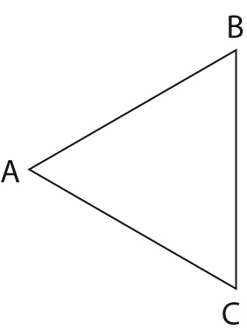 | AB = BC = CA | none
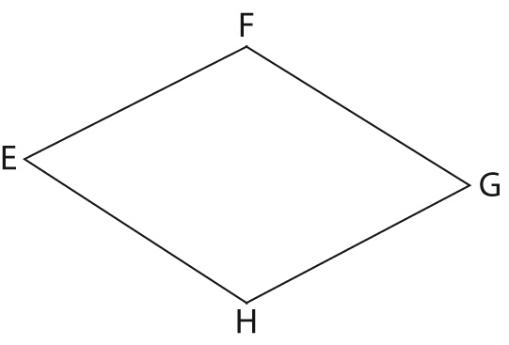 | EF = FG = GH = HE | EF and HG; FG and EH
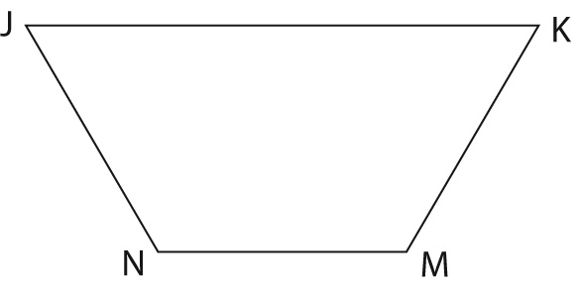 | JN = KM | JK and NM
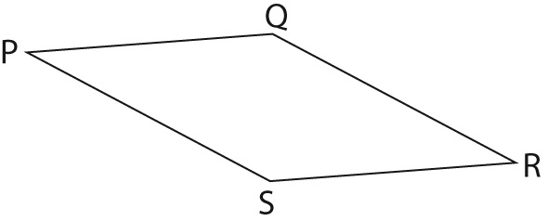 | PQ = QR = RS = SP | PQ and SR; PS and QR
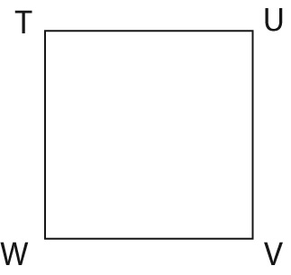 | TU = UV = VW = WT | TU and WV; TW and UV
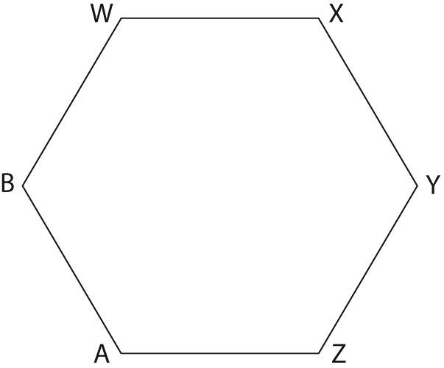 | WX = XY = YZ = ZA = AB = BW | WX and AZ; XY and BA; BW and ZY
Extra Practice 2 – Master 6.32
Lesson 2: Investigating Perpendicular Sides
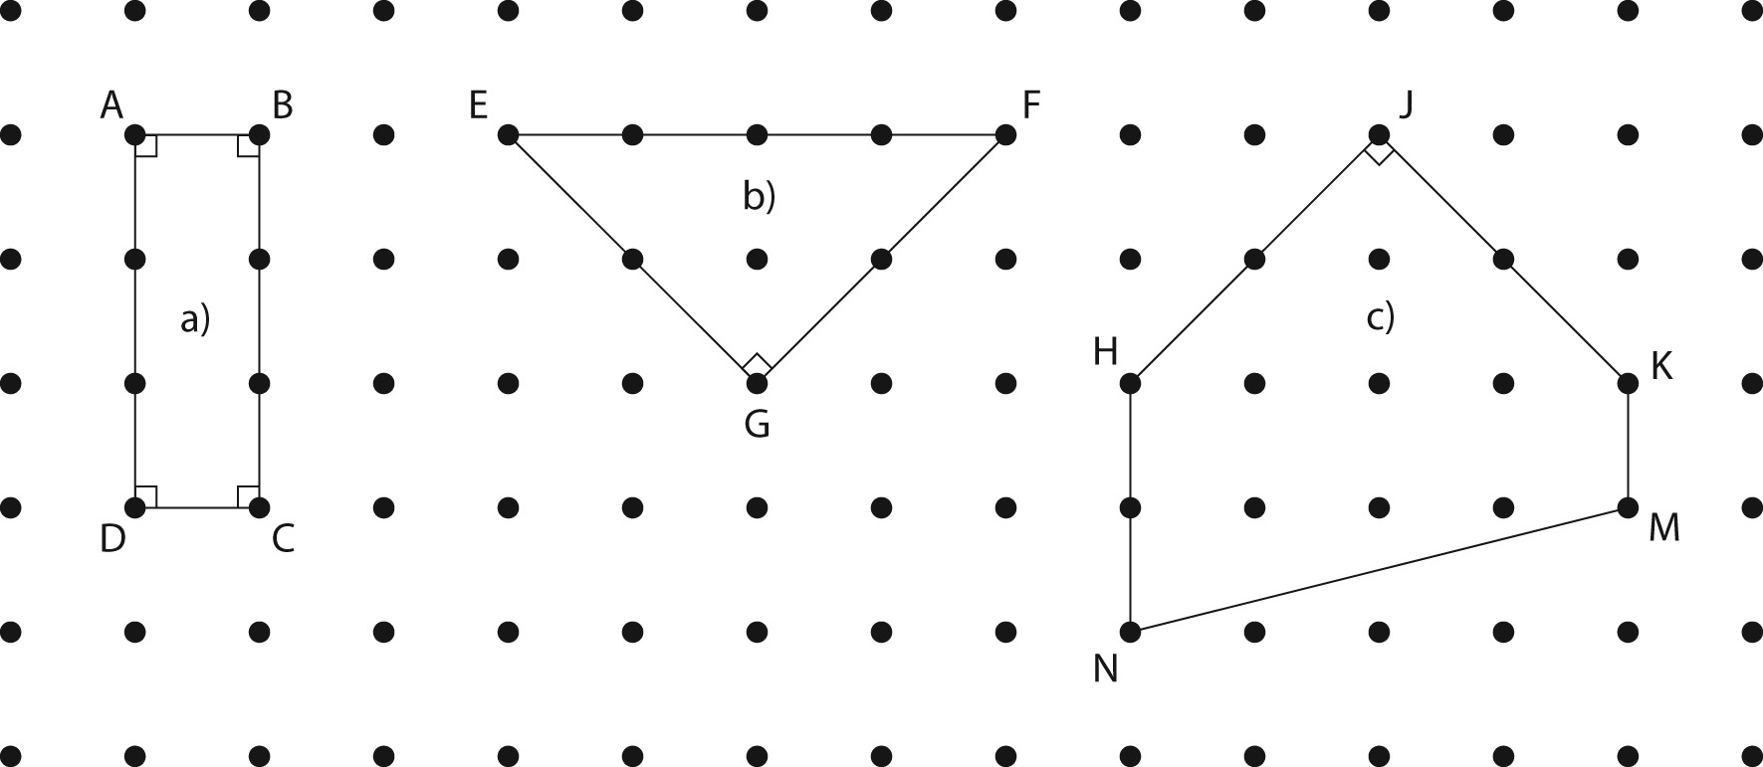
1. Shapes and labels on vertices may vary.

2. a) AB, DC, EF b) AD, BC, HN, KM
c) AB and BC; BC and CD; CD and DA; DA and AB; EG and GF; HJ and JK
Extra Practice 3 – Master 6.33
Lesson 3: Investigating Quadrilaterals
1. a) square b) trapezoid c) kite
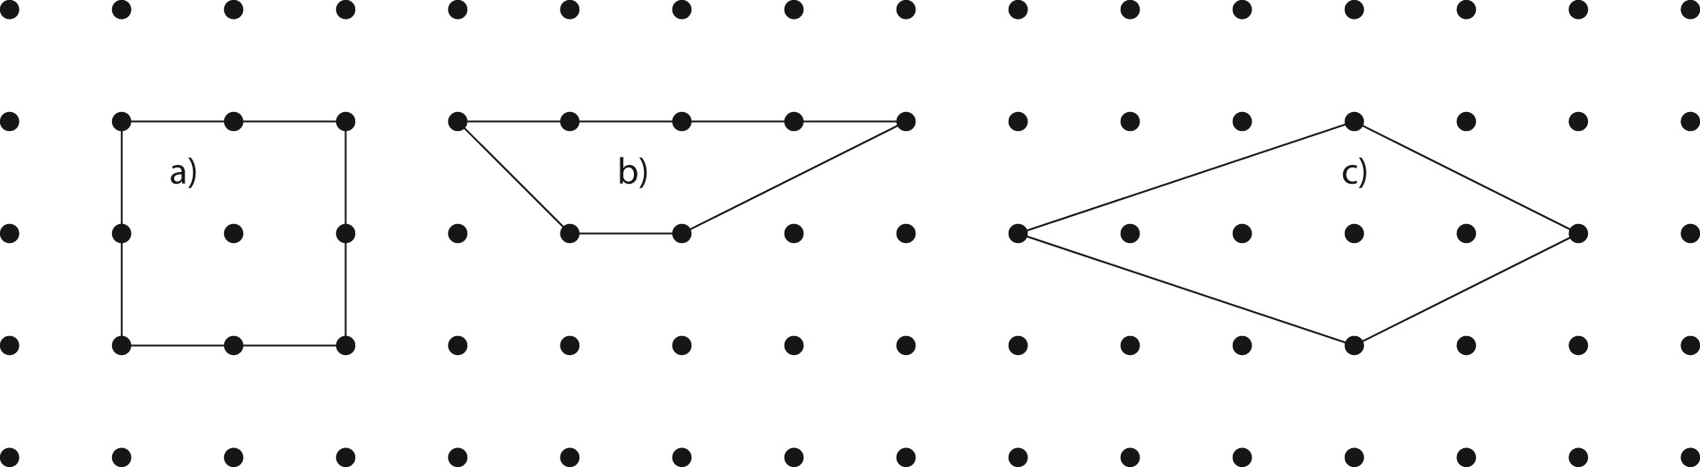
2. Shapes may vary in size.

3. a) Diagonals are perpendicular.
b) No further attributes
c) The equal sides are adjacent.
The diagonals are perpendicular.
Extra Practice 4 – Master 6.34
Lesson 4: Other Attributes of Quadrilaterals
Shapes may vary.
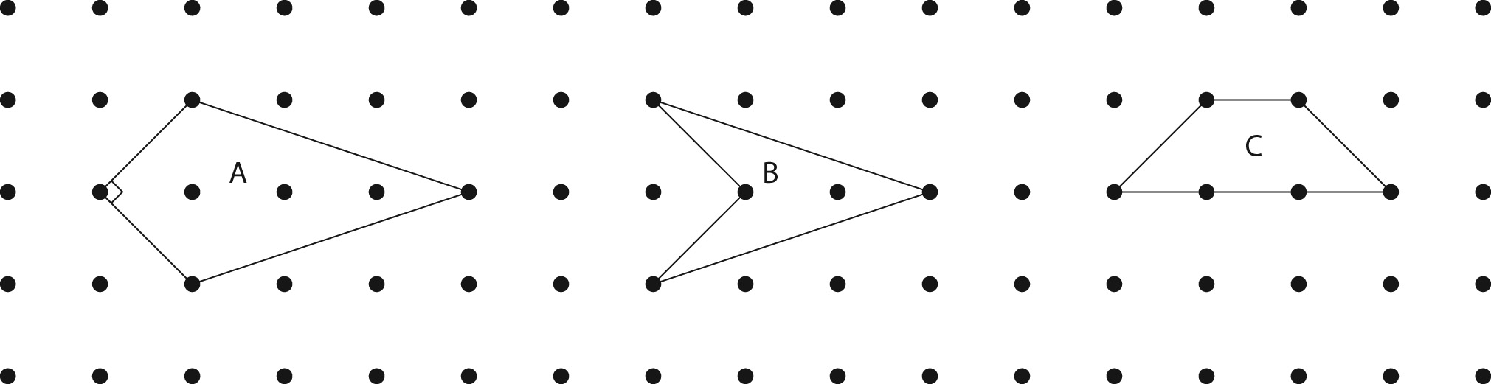
1. a)

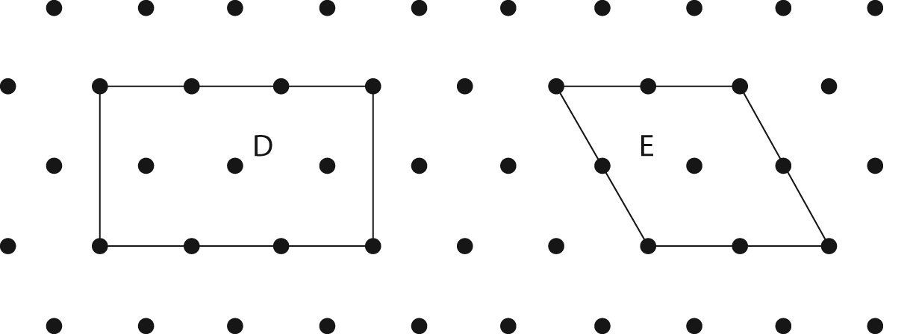
b)

c)
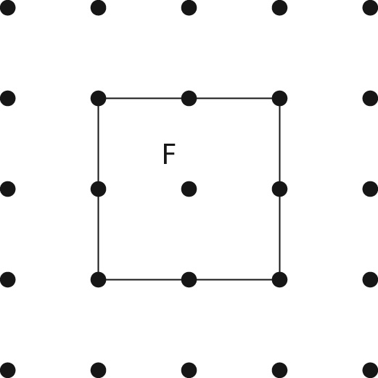

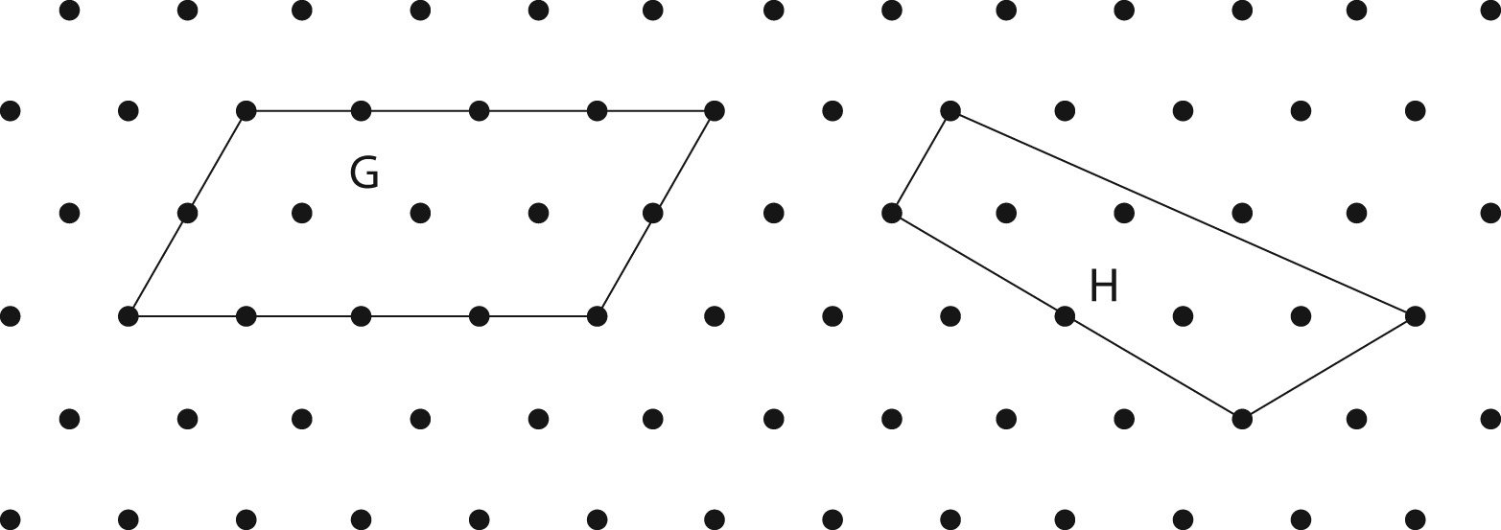
d)

2. Answers may vary depending on shapes and their labels. A, D, F
3. Diagrams will vary depending on the shapes and their labels.
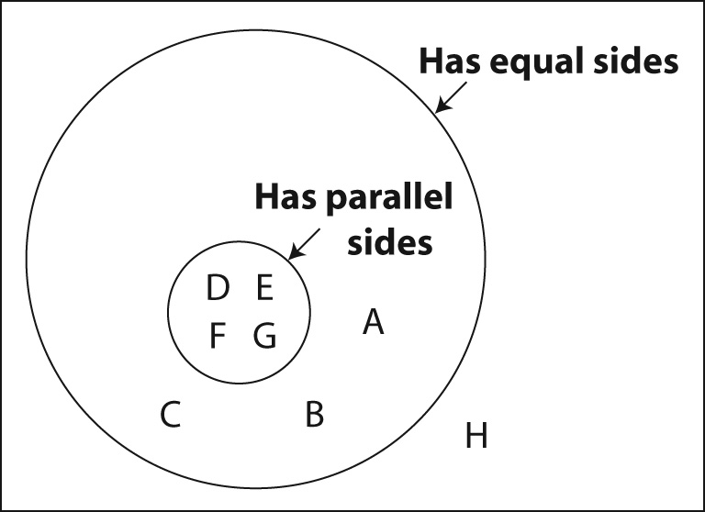

Extra Practice 6 – Master 6.35
Lesson 6: Exploring Faces and Edges of Objects
1. Answers may vary.
a) none b) none
c) AGB, AGF d) none
e) BCDEFG f) GB, ED
g) none h) AG, FG
i) none j) GB, BC
2. a) HJQR, MKPN b) HJQR, JQPK
c) HJQR, RQPN d) HJKM, JQPK
e) HJQR, MKPN f) HJ, RQ
g) HJ, JQ h) JQ, RQ
i) HM, JK j) MK, NP
3. a) SRVUT, XWAZY b) SRVUT, RVAW
c) SRWX, SXYT d) TUZY, UVAZ
e) SRVUT, XWAZY f) UV, ZA
g) UV, VA h) XY, YZ
i) SX, RW j) XW, SR
4. a) none b) none
c) FED, FEB d) none
e) EDCB f) ED, BC
g) ED, DC h) FE, EB
i) none j) ED, BE
Extra Practice 7 – Master 6.36
Lesson 7: Drawing Objects
1. a) square prism or rectangular prism
b) triangular prism c) hexagonal prism
2. Sizes and orientations of prisms may vary.
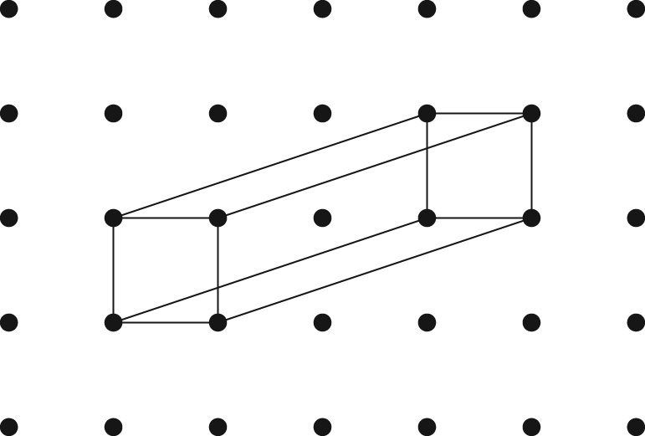
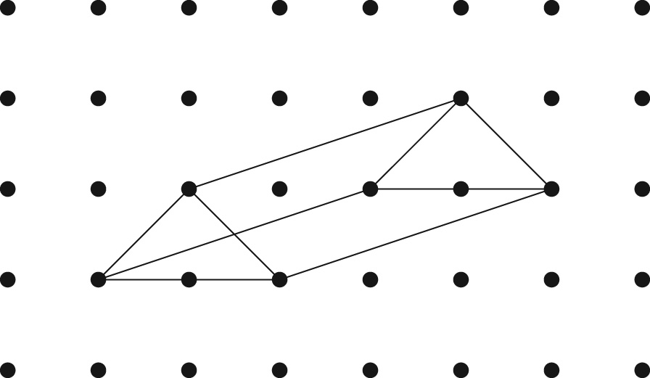
a) b)

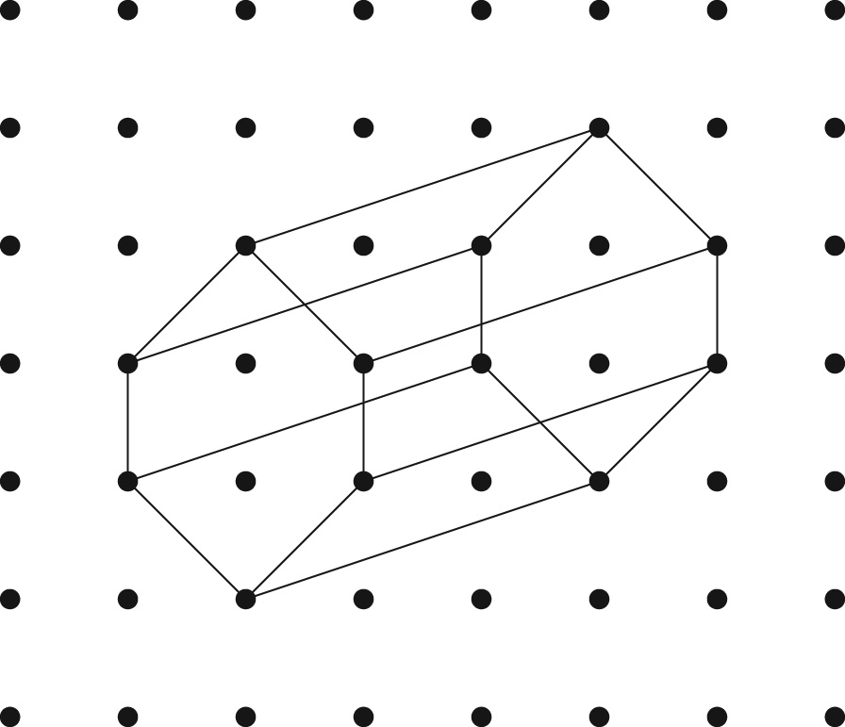
c)

3. a) triangular pyramid b) square pyramid
4. Sizes of pyramids may vary.
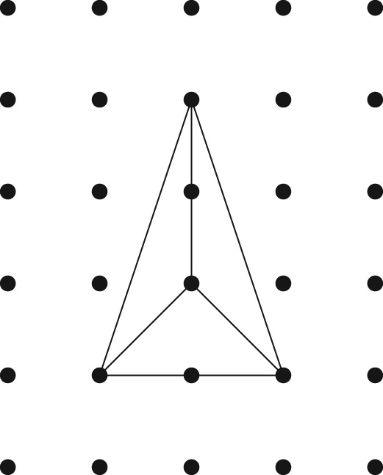
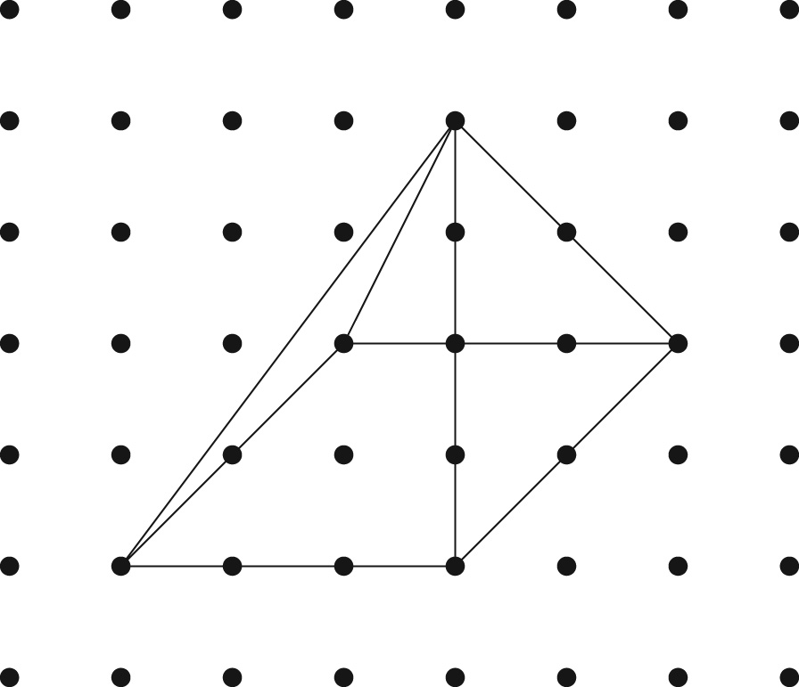
a) b)

